Debating
Tutorial
Handouts

By Colm Flynn
University of Limerick, Ireland.
Auditor Deb U 1996-97
Speaker WUDC Cork 96
Adjudicator WUDC Athens 98

Debating Tutorial:

These are the training handouts which I wrote a couple of years ago, in my capacity as Speaker Development Officer, in order to train the Maiden Speakers of the University of Limerick. They are by no means the ultimate guide to debating. In fact since I wrote them I have changed my mind about certain aspects and just have not had the time to re-write them.

The purpose of these is to provide a basic understanding of how to debate. They are intended to be a tool to help focus the progress of the workshops. Debating cannot be learned from a book. Experience is invaluable and maiden speakers must be encouraged to attend Intervarsities as soon as possible.

Also note that these are for British Parliamentary style of debating. While this is very different to American, Canadian, Australian, etc. styles it is the style that Worlds Council voted in 1996 to accept as the standard for all Future World Championships.

- General Rules and Guidelines to debating.
- Speaking Order in a Debate
- Researching your motion
- Structure of a Speech
- Speaking style
- Points of Information

General Rules/Guidelines for Debating

The aim of this page is to give you an idea of how to debate. It's not just a simple case of standing up and saying the first thing that comes into your head. There are certain rules and guidelines which have to be adhered to if you want to have any chance in a competitive debate.

This is not the page with all the answers. It is only a rough set of guidelines to help get you started. Everyone should try to find their own strengths and failings.

In the Debating Union we practice British Parliamentary style, which is now the official style of the World Championships. In the U.S., Canada, etc. a very different style is practiced.

1. Speeches should be SEVEN minutes in duration. Speakers exceeding this may be penalised but should never be substantially less than this. In general you should speak for at least 6:45 and generally no more than 7:20-7:30. Ideally stay on your feet until you hear the 7th min bell and then finish (i.e. Mr. Speaker sir, I beg to........) and be in your seat by 7:15. Your times will be recorded by the timekeeper and given to the adjudicators as they leave to make their decision.

2. In general most debates are in English. The main competitions are all in English but occasionally there are Irish debates usually in conjunction with some other event/soc.

3. A bell will be rung after the expiration of one minute and six minutes. The bell will be rung again at seven minutes and at regular intervals after that.

4. If the chair of the debate is the head of the host society he/she usually has a title e.g. Speaker, Auditor, etc. Here the proper form of address is Mr Speaker/Madame Speaker. You must also acknowledge the adjudicators, if there are any.
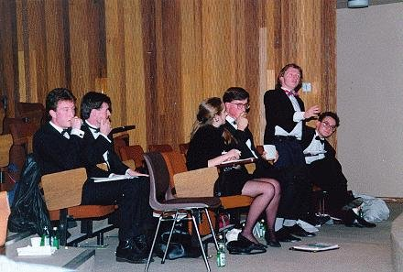
Some speakers will also acknowledge other members of the house, it is basically just a matter of personal preference as to how you begin your speech after acknowledging the chair and adjudicators. (e.g. "Mr Speaker, Madame Secretary, Adjudicators, Ladies & Gentlemen........................).

5. Points of information may only be offered after the expiration of one minute and may not be given after the expiration of six minutes. Points of information may only be given to opposing speakers and should generally be not more than 15 seconds in duration. The chairman may request a speaker to end a point of information at his/her discretion. Barracking (constantly interrupting the speaker by offering points) is also frowned upon by adjudicators and the chair is expected to control this. Acceptance of points of information is at discretion of the competitor holding the floor. In competitive debates only the competitors may offer points of information however in non-competitive debates points will often be accepted from the audience. Once you have accepted a point of information you can't just ignore it and carry on. You must deal with it or risk the adjudicators wrath.

6. Maiden speakers (i.e. speakers making a speech for the first time) have the protection of the chair. Other speakers may not offer them points of information unless they choose not to accept the protection of the chair. Even if they reject the protection of the chair most experienced speakers will not offer them a point unless they run into difficulty and it can help them. If you are good enough (or misfortunate enough depending on how you look at it) to be making your maiden speech in an intervarsity (rare but it has been known to happen) you do not have any special protection.

7. Points of order concerning the procedure of the debate must be addressed to the chair. These can be brought at any time and take priority over all other speeches. However these are only used in exceptional circumstances when the rules and standing orders are being abused and the speaker making the point must be certain that the point of order is appropriate. Any abuse of points of order will be penalised by adjudicators and in general these are avoided by most speakers.

8. Speakers must observe Parliamentary language i.e. bad language is not permitted.

9. The use of Props is not permitted in a debate.

10. No amendment to the motion is permitted. You must debate the motion as presented and interpret it as best you can.

11. The "house", which will often be referred to, is basically the chairperson competitors audience etc.

12. The speakers are evenly divided on both sides of the motion. Speakers for the motion are the "Proposition" or "Government", speakers against are the "Opposition".

13. The opening Prop speaker (sometimes called "Prime Minister") has to define or interpret the motion. If this definition is unreasonable of irrelevant then the opening opposition speaker may challenge the definition. But if the definition is relevant but just doesn't suit the opening opp. speaker attempting to redefine may not go down well with the adjudicators. If a definition is given and all the other speakers or teams completely ignore it then the defining speaker is effectively out of the
debate.

14. The last speaker on each side is expected to sum up his/her side's argument and rebutt or refute the arguments of the other side. Generally this speaker will not add a great deal of new information to the debate.

15. Rebuttal is vital in any competitive speech. Any argument left unchallenged is allowed to stand. The later you come in a debate the more rebuttal you must use. Rebuttal basically involves ripping the opposing sides argument apart and exposing its weak points. However don't forget to make your own argument and ideally use that to rebutt.

16. Be careful to avoid leaving statements hanging in mid-air. If you say something important back it up. Just because you know something is true and where it came from that doesn't mean the audience/adjudicators know where it came from and why it's true. To a certain degree the safest bet is to assume that the audience know little or nothing about the subject.

17. Just because you may not be competing this does not mean that you can take no part in the debate. All debates are usually opened up to the floor after the last speaker and once the adjudicators have retired. Often there is a prize for the best speaker here, but time allowed is usually no more than 3 min. to allow as many people take part as possible.

18. Heckling is also common in some debates. This involves members of the audience offering some good humoured abuse to the competitors. However there is a fine line between heckling and barracking and members of the audience should remember to respect the speaker. Heckling can be scary at first but you will soon get used to it.

19. Private Members Time, PMT, is a period of time at the start of each debate where members may bring up a motion or issue which they wish to see debated. Speeches here are limited to 3 min. This is often a part of the debate which is not only used to raise issues but also where many speakers show off their wit and humour.

20. Remember you do not necessarily have to believe the side of the motion you are on. You just have to make it appear as though you strongly believe in it for 7 min. In competitive debates you will have very little choice as to which side of a motion you get.

21. No matter how bad you think your speech is try to stay up for the full seven minutes. If the audience is giving you a hard time just remember that they probably want you to walk off so don't give them the pleasure. If the chair doesn't control the audience ask him/her to and put him on the spot with the adjudicators. Of course you have to be able to handle a reasonable amount of heckling.

22. You don't have to be a genius for facts and figures to do well. If you can remember an example, or fact which you researched, to back up your argument use it. However if you get stuck and think that a fact, figure or example is needed and you don't have one, try making one up. It can be risky if you get caught by a member of the opposing side who actually knows what they are talking about (it can be painful, believe me) but it can be very effective if you get away with it. This is not, however, a replacement for good research, only a fall back if you're in trouble.

23. If you can use humour it can be extremely effective in a debate. You can ridicule and destroy an opponents whole speech with a one line joke attacking it. But don't go over the top, while humour helps, adjudicators may not be impressed by stand up routine with little substance. Although humour can be an advantage don't worry if you can't crack a joke to save your life (or speech). You'll be surprised at the number of speakers who have to really struggle to include humour in a speech while others do it with ease

Speaking order:

The speaking order depends on whether it is individuals or teams, or both, and the style being used in the competition but it generally follows either "Times" or "Mace" format;
Individuals:
(1.) Opening Prop.
(2.) Opening Opp.
(3.) 2nd Prop.
(4.) 2nd Opp.
(5.) 3rd Prop.
(6.) 3rd opp.
(7.) Last Prop.
(8.) Last Opp.
Teams:
Irish Times:
(1.) 1st speaker from opening prop.
(2.) 1st speaker from opening opp.
(3.) 1st speaker from 2nd prop team.
(4.) 1st speaker from 2nd opp team.
(5.) 2nd speaker from opening prop.
(6.) 2nd speaker from opening opp.
(7.) 2nd speaker from 2nd prop.
(8.) 2nd speaker from 2nd opp.

Mace/Worlds:
(1.) 1st opening proposition.
(2.) 1st opening opposition.
(3.) 2nd opening proposition.
(4.) 2nd opening opposition.
(5.) 1st closing proposition.
(6.) 1st closing opposition.
(7.) 2nd closing proposition.
(8.) 2nd closing opposition.

If there is a mixture of teams and individuals (e.g. in Times final) the Individual speakers are inserted in the middle of the debate i.e. after the first speaker for the last team and before the last speaker for the for the first team.

(1.) 1st speaker from opening prop.
(2.) 1st speaker from opening opp.
(3.) 1st speaker from 2nd prop.
(4.) 1st speaker from 2nd opp.
(5.) 1st proposing individual.
(6.) 1st opposing individual
(7.) 2nd proposing individual.
(8.) 2nd opposing individual.
(9.) 2nd speaker from opening prop.
and so on.
Naturally the actual order depends on the number of teams/individuals debating.
Research

Research is vital and cannot be avoided if you want to make a winning speech. Some people say that only a small portion of your research should appear in your speech and the majority will come into play later. I have yet to see the "later". This may be in the form of points of information but that is assuming that you can predict what information you will need to contradict what the speaker says. If you have information don't keep it to yourself, USE IT.

Look for facts and examples more so than statistics. While statistics can very handy for filling up a few minutes, they are also boring. Your information should back up your argument and be memorable. If you find a little known fact that will surprise the audience and catch their attention use it strategically. Place it at a crucial stage of your speech in a way that everything falls in together and the audience becomes convinced of the truth of what you are saying. Remember that your argument is the most important part of your speech and your research should back it up, not the other way round.

There are invaluable sources of information all around and you will very rarely come across a motion which you can find absolutely no information if you look hard enough.

Library:
Although we may complain about our library it is still an invaluable source of information. Look around the sections which relate to your motion and flick through a few books that look relevant. A good source of historical information are the "Chronicle" style, black bound, journals in the history section. These are updated monthly. If you don't know where to go for information take the keywords from the motion and type them into an OPAC terminal. It should give you the book references you need.

Journals Section:
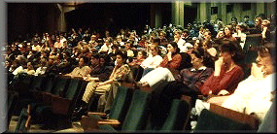
This is easily the best source of information on campus. If you have a motion dealing with a topical political, cultural, or scientific subject then the first thing you should do is look through the back issues of Time and Newsweek. These contain a huge amount of information and not only on current affairs. If you've never read them it is well worth spending a short time flicking through them so that you get a feel for the sort of information they carry and where to find it if you need it later. If you want more information then there is bound to be some information about it in other more specialised journals but it may be harder to find. You could also look up the past issues of newspapers on microfilm but you really would want to know exactly what you are looking for.

T.V. & Radio:
While it is unlikely that RTE will oblige you by broadcasting a program dealing with the subject behind your motion while you are preparing for it you can still use them for information. If you know that there is a documentary, special report or debate on a topical issue why not watch, or listen to, it. You don't have to go out of your way or sit there taking notes like a lecture but if you have nothing better to do you might be surprised how much of it you will remember if it comes up later.

Brainstorming:
This involves a group of people getting together to discuss a motion and come up with ideas. The group meets in a room and trash out the various issues involved from a definition and line to examples and the other sides possible strategy. One member writes down all the ideas and this is best done on a blackboard so a tutorial room is sometimes used. However these can also become side-tracked (one I was at lasted over three hours and only twenty minutes were spent discussing the motion). If used effectively they should work well and we may start doing them on a more regular and organised basis. Even if you don't want to hold a brainstorming session don't be afraid to ask other debaters for ideas, most will be glad to help and may even have debated the motion before.

There are many other sources of information if you know where to look. Perhaps the best source is your own memory. If you remember some fact but are hazy on the exact details of where or when you heard it don't be afraid to use it. A debate isn't an exam so the information you use doesn't have to be 100% true just sort of, from a certain point of view of course.

Structure of a Speech.

Ideally you should try to have a structure to your speech. If you do then it is more likely to be a good speech. If you don't have some form of structure you may be penalised by adjudicators and you may ramble. You don't have to use a strict structure just have a mental layout of what you want to say and when. In fact if you have too rigid a structure then you will find it impossible to stick to it, when you have to rebutt and deal with points of information.
The following is a rough outline of how to structure your speech.In general just use these as guidelines and, ideally, develop a style and structure which you are comfortable with.

1st Minute (0:00-1:00):
(Can't be given a point of information).
Win the audience, perhaps with a joke.
Don't rebutt another speakers speech.
Define your speech, i.e. say what you will address and how. Ideally be able to state your argument in a single, short sentence.
Define your team approach i.e. say, roughly, what your partner will say (or has said).

2nd Minute (1:00-2:00):
Don't take any Points of information until foundation has been laid i.e. until you have developed your speech a bit.
Layout your argument.
Usually best to propose/oppose on 3 points. (e.g. Political, Economic, Social).
Begin your first point.

3rd-6th Minute (2:00-6:00):
Accept 2 to 3 points of information. Say outline political aspects and deal with them. Then take a P.O.I. on that. Do the same for the other aspects (i.e. Economics & Social).
Use these four minutes to make all your points. Effectively this is your speech.
Refer back to the single, short, core sentence one or two times.

7th Minute (6:00-7:00):
Once the sixth minute bell has gone you can't be offered any points of information.
Finish the point you were on as quickly as possible.
Don't introduce any new points or arguments.
Sum up. Reiterate your main points and arguments (and those of your partner if you are the second team speaker.).
Ideally, if possible, restate the single, core sentence as the last thing you say.

7:00 min:
Stay on your feet until you hear the bell.
Finish, immediately if possible, "Mr Speaker, Sir, I beg to ...............".
Be back in your seat by 7:15, if possible, and no later than 7:30.

8:00 min:
You are dead. Sit down before you make a complete fool of yourself.
Speaking Style

One thing you are bound to notice at any debate is the different speaking styles used by the competitors. Speaking style is perhaps one of the most difficult aspects of debating to attempt to "teach". You will have to develop your own style and preferably one that comes naturally to you. However there are a couple of things to be kept in mind.

1. You must speak clearly and loudly enough so that your voice can be heard by everyone. Remember the adjudicators will sit towards the rear of the hall so at the very least they must be able to hear what you are saying if you are to have any chance of winning. However you shouldn't shout as the halls have generally been designed so that your voice will carry towards the back.

2. Try to avoid monotone. If you are making an important point use your voice to stress it and make it stand out. Try to slowly increase the stress and force behind your voice as you go through your speech. Build up to a high point and make this the crucial point of your speech. However don't bring the audience on a rollercoaster ride. Don't start high, fall down, build-up and fall down again, it looks as though you are only convinced about the truth of half your speech.

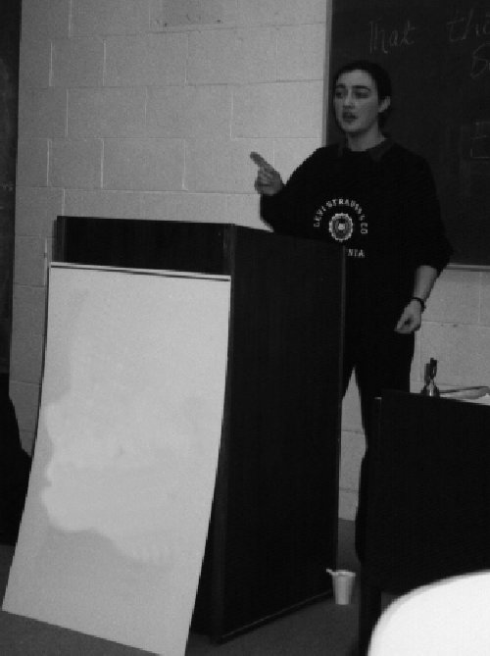
3. Keep eye-contact with the audience and don't stare at the podium. It gets easier to do this after some experience and once you use fewer notes. Some people like to pick out individuals in the audience and look at them. Others just speak to the audience as a whole. However you do it make sure to scan the audience and move your gaze to different parts of the hall regularly.

4. Use your body language to back up your speech. If you stand rigidly and don't move then you will find it very difficult to have any real conviction in your voice. Use your arms and facial expressions to convey your emotions and back up your speech. However don't go overboard, you want the audience's attention to be focused on your speech not your arms. Try not to have anything in your hands. Some people like to carry a pen and end up waving it about like a baton which can distract the adjudicators. If you really need something use index cards.

5. You don't have to stand strictly behind the podium. Move around a bit and face different sections of the audience at different times. Apparently studies have shown that people tend to prefer to be able to see the whole person as this is supposed to indicate that you aren't hiding anything. However, once again, don't go overboard. It annoys people (and more importantly adjudicators) if you walk too far from the podium. Try not to go more than 1-2 meters away from the podium. One way to ensure this is to leave your notes on the podium, you'll find yourself reluctant to move too far from them.

6. Don't be too complicated. If your argument is too elaborate people may have difficulty following it. Don't use 15 syllable Latin words when a 2 syllable English word will do. Remember you are trying to convince the audience that your argument is the best and not that you consider your talent wasted on them (even if it is).

7. Use humour to help win over the audience and make your speech stand out. If you have a natural talent for comedy or impersonations etc. then use it. If you don't then don't worry about it, even the most serious of us can be funny at times (often even without meaning it). You can work out a few put downs and one-liners in advance but be careful. If a joke sounds too prepared than it may bomb. Try to make it sound spontaneous and it's more likely to be successful.

The best thing to do is watch other speakers and see how they combine the various elements. Experiment with different styles and try to find one that you are comfortable with. However the only real way to develop a good style is to try to speak on a regular basis and listen to the advice of adjudicators and the more experienced debaters.

Points of Information

Points of Information are a vital part of any debate and should not be underestimated. Before and after your speech you can't just sit quietly and enjoy the other speeches. You must keep the adjudicators aware of your presence, ideas and argument. Also P.O.I. can be used as a weapon to undermine, and even destroy, an opponents speech.

Presentation:
When giving a point of information you are expected to stand up, hold your left hand out (place your right hand on your head, honestly!) and say "On a point of information sir". Different people use slight variations on this but this is the basic one. Often speed is important to get in first, but that is no guarantee that you will be accepted. So you should make sure that you have enough space to stand up quickly and at a split second's notice (without sending your notes flying towards the podium). If you can do without a bench for writing, then a front row seat is ideal. If however you can't then use a seat at the end of a row so that you need only stand out to the side. Once you have been accepted stand facing the speaker at the podium but also try to half face the chair and audience, if possible.

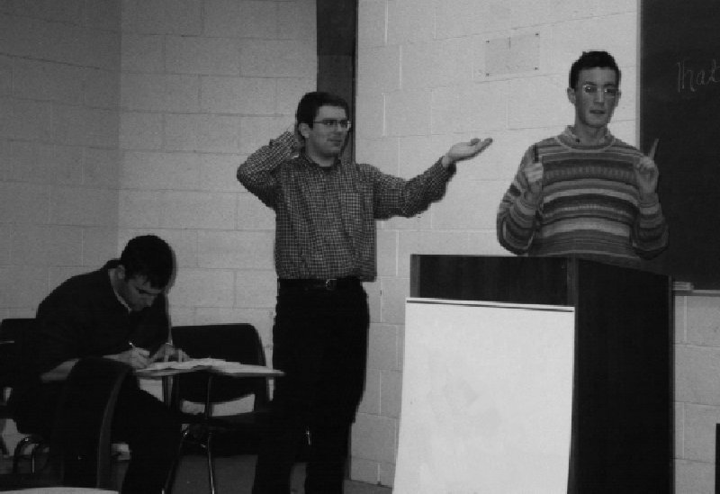
Keep your P.O.I. short and to the point. The max. time allowed is 15sec but you should try for between 5 and 10 sec. Remember that many speakers like to take a P.O.I. and then use the time to check what they will say next while half listening to the person offering the point. Once they know what the next part of their speech is they work out an answer to your point. If your point is only about 5 sec. in duration it doesn't give them enough time and is more likely to catch them (especially if the point is weak and wouldn't work well if they had time to think about it). It looks bad if they have to stop to think what to say, especially if they have to ask you to repeat it. But do not get involved in a discussion. If asked to repeat or clarify stand up to give the point but look towards the Chair & Adjudicators to make sure that they agree that you can offer the point.

Timing is important. If a speaker is in full stride and knows exactly where they are going for the next few seconds, he/she is unlikely to accept a point. Wait for a pause, for breath etc. by the speaker and then offer the point. Obviously you have to be quick and good reflexes are needed to be on your feet literally within a split second. I've found that a point is more likely to be accepted in this type of case but you can't wait for too long as the point could then be out of place.

Styles:
Different people have different styles when it comes to Points of Information. Some people (no names) like to virtually barrage opposing speakers with every point which pops into their head. This can be very difficult to deal with and takes some getting used to. The trick is to just ignore it if possible and make your speech. If you decide to use this type of style be very careful. It has been known to annoy adjudicators if taken too far and there IS a precedence for having speakers disqualified.

Most speakers prefer to just wait and see how a speech develops. This involves leaving weak points go and use just one or two attacking the central core of the speech once it has developed a bit.

Accepting:
When you are speaking you should accept 2-3 points. Watch out for good speakers. If someone has killed off every other speaker on your side be careful and don't assume that you can handle them. Accept someone else ideally someone who has been offering poor points all night. Points should not be longer than 15 sec. but you can cut that person off before this if they are making a very poor point and particularly if you have a good put-down to use on them. Always deal with the point that is offered. Never accept a point as true, unless the offerer has made a mistake and it backs up your argument. Always try to dismiss a point as incorrect or irrelevant. A point ignored is allowed to stand and will go against you in adjudication.

Rejection
If you have offered a point of information and it has been rejected don't make it anyway, this annoys adjudicators. However if you have been constantly rejected don't be afraid to show your "frustration". Gestures, Facial expressions etc can convey the message that you believe that the speaker is afraid of you. This works especially well if you have been standing waiting to be accepted and someone else has been accepted who just stood up.

